**Easy Homes Documentation:**

|  |  |
| --- | --- |
| **Name** | Easy Homes |
| **Team** | Group 24 |
| **Contributors** | Daman deep Kaur(B00904831),  Qinyue Wang(B00892024),  Shaik Asaduddin(B00894318),  Keyur Vaghani(B00901000),  Radhey Rupapara(B00910695),  Dhruvrajsinh Vansia(B00891415) |
| **TA** | Harit Patwa |
| **Technology** | Spring Boot, JPAs and ReactJs |
| **Cloud** | Heroku |
| **Database** | MySQL |
| **Status** | Completed |

**Problem Statement**

Building a web application that helps users to find the properties available for rent or sale, and the services available across the city.

**Technology Used**

|  |  |
| --- | --- |
| **Backend** | Java with Springboot |
| **Frontend** | React Js |
| **Cloud** | Heroku |
| **Database** | MySQL |

**User Scenarios:**

1. **User Management:**

|  |  |
| --- | --- |
| **Use Case Number** | 1 |
| **Use Case Name** | User Registration |
| **Input** | First Name, Last Name, Email Address, Password |
| **Output** | The user would be sent a confirmation link to mail, which if confirmed, then User Registration will be done. |
| **Description** | To start using the service of Easy Homes, the user first needs to have an account on the Easy Homes platform. For doing this, there is a button on a login |

|  |  |
| --- | --- |
| **Use Case Number** | 2 |
| **Use Case Name** | Login |
| **Input** | Email address, Password |
| **Output** | The user would be logged in and sent to the dashboard after he/she enters the correct email and password. |
| **Description** | To start using the services of Easy Homes, the user must be logged in first. Whenever the user goes to easy homes, he/she will be prompted to log in. After entering the correct email id and password, the user would be logged in successfully and sent to the Dashboard where he/she can start using the features of Easy Homes |

|  |  |
| --- | --- |
| **Use Case Number** | 3 |
| **Use Case Name** | Forgot Password |
| **Input** | Email Address |
| **Output** | OTP is mailed, which needs to be entered to reset the password. |
| **Description** | Sometimes it happens, that the user forgets the password, which was set by him, Taking the scenario into consideration, the forgot password feature has been kept so that, if it happens, the user can reset the password set by him/her, to start using the features of Easy Homes, without losing their confidential data saved in their account. |

1. **Property:**

|  |  |
| --- | --- |
| **Use Case Number** | 4 |
| **Use Case Name** | Properties Dashboard |
| **Input** | Login |
| **Output** | Users can access all properties listed on the Easy Homes platform. |
| **Description** | Once the user Enters the Easy Homes platform, he can start using the features of Easy Homes. By default, he/she will be on the property page. All the properties available for rent or sale can be seen here. Users can add a post for the property available for sale or rent if he has any. |

|  |  |
| --- | --- |
| **Use Case Number** | 5 |
| **Use Case Name** | Post a property |
| **Input** | Property Name, Property Type, Bedrooms#, Rent, Amenities, Address, Images |
| **Output** | The property would be added to the feed. |
| **Description** | If the user has property available for rent or sale, then he/she can fill in all the details available and useful for other users to get information about the property. After the successful posting of the property, all the users on the easy homes platform can see the post for the property added by the user. |

|  |  |
| --- | --- |
| **Use Case Number** | 6 |
| **Use Case Name** | Edit/Delete a property |
| **Input** | Property Name, Property Type, Bedrooms#, Rent, Amenities, Address, Images |
| **Output** | The property would be modified or deleted. |
| **Description** | If the user made some mistake or some details of the property change in the future. The user has the facility to modify the changes to the property. Also, if the need of selling or renting a property is gone, then the user can delete the post of the property so that, other users can’t query about the sold property. |

|  |  |
| --- | --- |
| **Use Case Number** | 7 |
| **Use Case Name** | Adding property or services to favorite |
| **Input** | Click the heart button on the service or property. |
| **Output** | The property or service will be sent to your favorite list menu |
| **Description** | If the User likes some property or service and needs to keep that service or property saved for using it in the future, then he/she can save that service or feature to a favorite, so that it can be used by them in the future. |

|  |  |
| --- | --- |
| **Use Case Number** | 8 |
| **Use Case Name** | Removing property or services from favorite |
| **Input** | Hit the cancel button from the favorite list for the property or service. |
| **Output** | The property or service would be removed from the property. |
| **Description** | If the user no longer needs the property or service to be saved in the favorite list, then he/she could just remove it by hitting the cancel button seen in the favorite list. And the property or service would be removed from the |

|  |  |
| --- | --- |
| **Use Case Number** | 9 |
| **Use Case Name** | Chat between customer and owner |
| **Input** | Message |
| **Output** | Message |
| **Description** | If the user finalizes any property or service and needs to enquire about the same for the owner then they both could chat about it in the chat section. |

|  |  |
| --- | --- |
| **Use Case Number** | 10 |
| **Use Case Name** | Advanced Search for a property using the filter option |
| **Input** | Property Name, Property Type, Bedrooms#, Rent, Amenities, Address, Images |
| **Output** | Filtered Search |
| **Description** | If the user has some requirements for the property, then he/she can filter the properties according to their need. By doing this, he/she could see just the properties that he needs. The user just needs to enter his requirements on the left side of the page. |

|  |  |
| --- | --- |
| **Use Case Number** | 11 |
| **Use Case Name** | Notification for scheduling a meeting for a property deal |
| **Input** | Buy a property |
| **Output** | Notification in mail |
| **Description** | Email Notification on buying property will be sent to the user. |

1. **Services:**

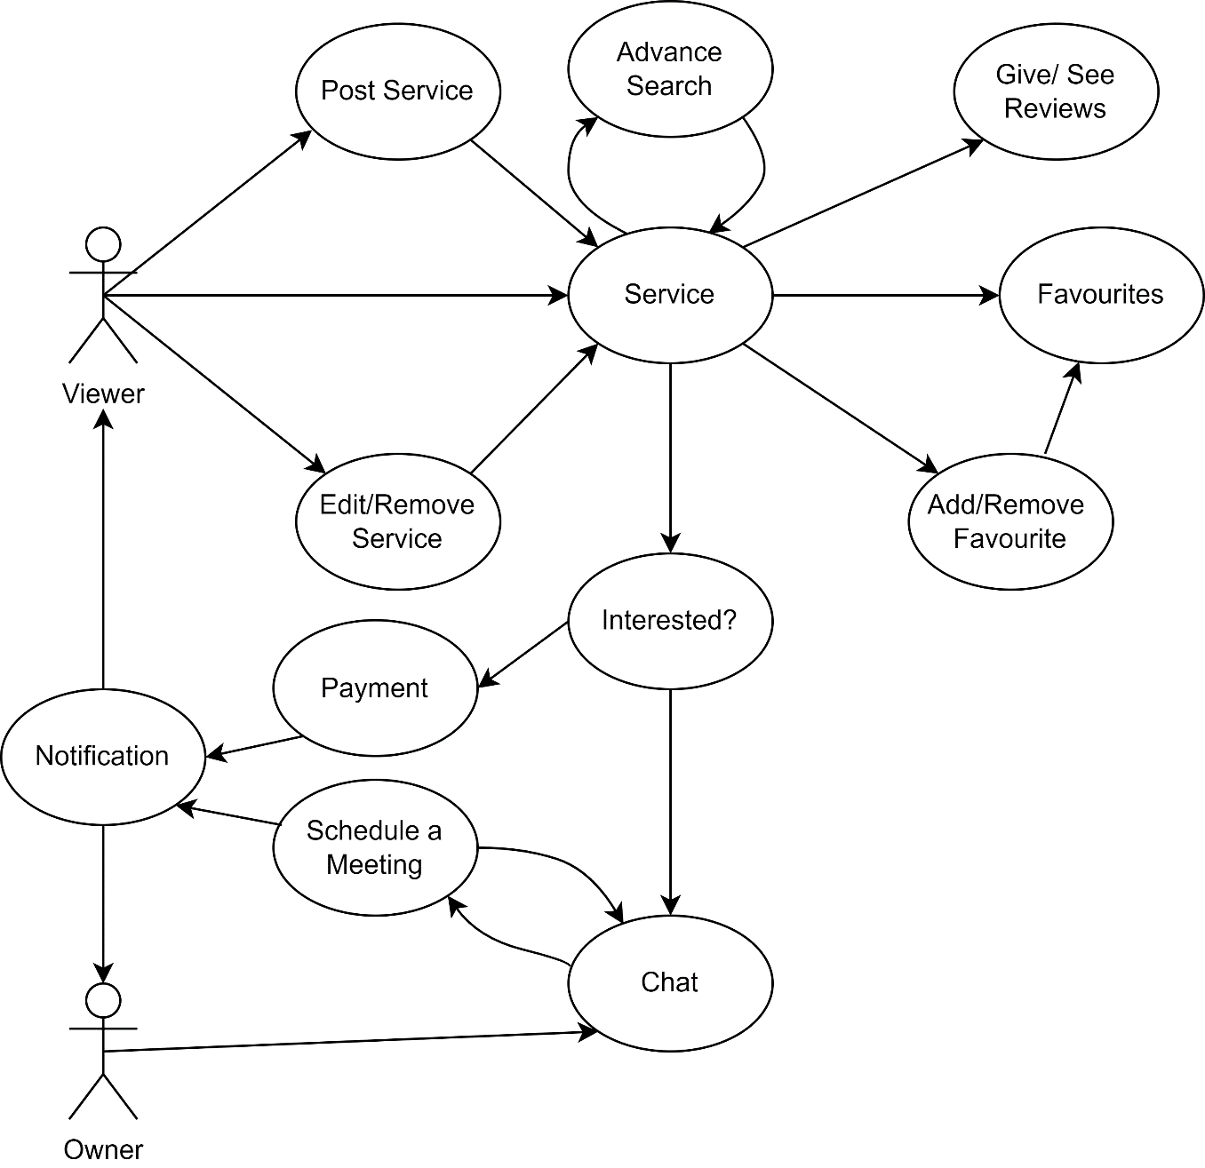

|  |  |
| --- | --- |
| **Use Case Number** | 12 |
| **Use Case Name** | Services Dashboard |
| **Input** | Clicking on the Services button which appears at the top center. |
| **Output** | Users can access all services listed on the Easy Homes platform. |
| **Description** | After clicking on the service button, the user will be taken to the service page which will display all the services that are registered on the Easy Homes platform. All these services can be seen viewed used and can be reviewed. If the user wants to add a new service, he can also add that. |

|  |  |
| --- | --- |
| **Use Case Number** | 13 |
| **Use Case Name** | Post a Service |
| **Input** | Service Name, Service Type, Service Cost, Plan, Description, Address, Images. |
| **Output** | The property would be added to the feed. |
| **Description** | If the user is providing a service that can be useful to other users, then he/she can post the service on the platform. On the bottom right corner of the dashboard, there must be a button with which he can add the details of the services mentioned above. After the successful addition of the service, the user can now see the service which can be used by other users. |

|  |  |
| --- | --- |
| **Use Case Number** | 14 |
| **Use Case Name** | Service Reviews |
| **Input** | Click on Learn more in Services and scroll down |
| **Output** | Users can view the reviews |
| **Description** | To choose between the same service provided by different users, the user needs to compare bee services. It can be done by seeing the reviews which share the experience of the previous users who used the particular service. |

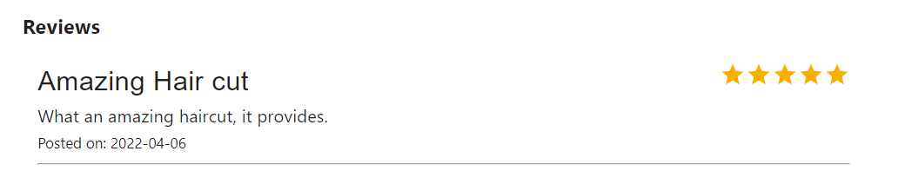

|  |  |
| --- | --- |
| **Use Case Number** | 15 |
| **Use Case Name** | Give Reviews to Service |
| **Input** | Subject, Description, Rating |
| **Output** | Seen by other users, to judge the service |
| **Description** | The services available in the market need to be reviewed so that other people come to know about, how was the review of the service. Through this, they can decide whether to utilize the service or not. |

|  |  |
| --- | --- |
| **Use Case Number** | 16 |
| **Use Case Name** | Edit/Delete a Service |
| **Input** | Service Name, Service Type, Service Cost, Plan, Description, Address, Images. |
| **Output** | The Service would be modified or deleted. |
| **Description** | If the user made some mistake or some details of the services change in the future. The user has the facility to modify the changes to the services. Also, if the user is no longer providing the service, the service can be removed from the platform by the user so that no one else can enquire about that service. |

|  |  |
| --- | --- |
| **Use Case Number** | 17 |
| **Use Case Name** | Buying a Service using PayPal |
| **Input** | Use PayPal to do transaction |
| **Output** | Service would be bought |
| **Description** | If anyone user needs to buy any service for him/her, he could use this feature. |

|  |  |
| --- | --- |
| **Use Case Number** | 18 |
| **Use Case Name** | Advanced Search for service using the filter option |
| **Input** | Service Name, Service Type, Service Cost, Plan, Description, Address, Images. |
| **Output** | Filtered Search |
| **Description** | If the user has some requirements for the service, then he/she can filter the services according to their need. By doing this, he/she could see just the services that he needs. The user just needs to enter his requirements on the left side of the page. |

|  |  |
| --- | --- |
| **Use Case Number** | 19 |
| **Use Case Name** | Book an appointment for service |
| **Input** | Select time to book an appointment |
| **Output** | The appointment would be booked |
| **Description** | If the user needs to use a service, he/she needs to book the appointment first for the service. To book the appointment, the user needs to go to book the appointment button and then select the time he needs to book an appointment |

|  |  |
| --- | --- |
| **Use Case Number** | 20 |
| **Use Case Name** | Notification for booking an appointment |
| **Input** | Book Appointment |
| **Output** | The user will receive an email for an appointment confirmation |
| **Description** | Whenever the user books an appointment for the service he/she will be notified with mail by a confirmation email. |

|  |  |
| --- | --- |
| **Use Case Number** | 21 |
| **Use Case Name** | Notification for buying a service |
| **Input** | Buy a service |
| **Output** | Notification in mail |
| **Description** | Email Notification on buying service will be sent to the user. |

|  |  |
| --- | --- |
| **Use Case Number** | 22 |
| **Use Case Name** | Logout |
| **Input** | Click on Logout |
| **Output** | The user would be logged out. |
| **Description** | When the user is done with his work in Easy Homes, he/she can just press the logout button so that he/she would be logged out from the Easy Homes platform. |

